**What is CloudFront?**

Amazon CloudFront is a web service that speeds up distribution of your static and dynamic web content, such as .html, .css, .js, and image files, to your users.

CloudFront delivers your content through a worldwide network of data centers called edge locations.

When a user requests content that you're serving with CloudFront, the user is routed to the edge location that provides the lowest latency (time delay), so that content is delivered with the best possible performance.

* If the content is already in the edge location with the lowest latency, CloudFront delivers it immediately.
* If the content is not in that edge location, CloudFront retrieves it from an origin that you've defined—such as an Amazon S3 bucket, a MediaPackage channel, or an HTTP server (for example, a web server) that you have identified as the source for the definitive version of your content.

Below Diagram help you in understanding how CDN works

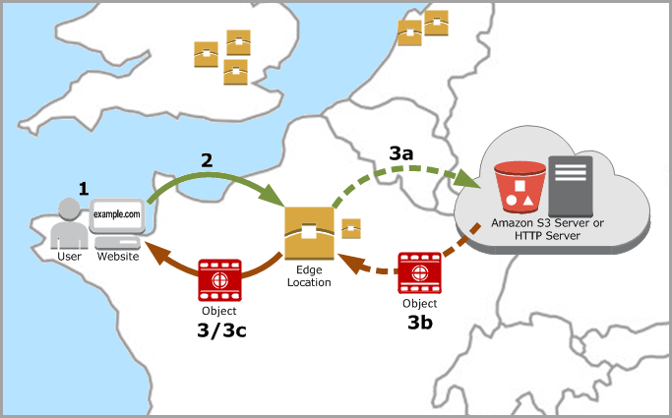

If we observe the above diagram the sequence of actions will be done in the following ways.

1. End users request your website Ex: <https://www.balluun.com> **(1)**
2. First, it will search in the nearest edge location **(2)**. If the content is not available it will request your web servers **(3a).**
3. Before delivering to your end user it will make cache in the edge location **(3b)** and then completes the request **(3c).**
4. Next time if the same user or different user requests your site it will search in edge location **(2)**. As it is already cached in the edge location it will load your site in a fraction of milliseconds **(3).**

This is how content delivery network service provides more value to your website.

**CDN Benefits:**

1. Fast and Global
2. It allows us to integrate with a lot of AWS services

**Pricing:**

With Amazon CloudFront pay-as-you-go pricing, you pay only for what you use.

Please have a look at the below AWS site to know more about the pricing.

<https://aws.amazon.com/cloudfront/pricing/>